**CAI Camera Control Installation**

Before installation, please make sure you have gphoto2 library installed in your Mac computer.

Install Macport developer tool:

1. Download macport from <http://www.macports.org/install.php> and select your OS version.
2. Install MacPorts to your computer.

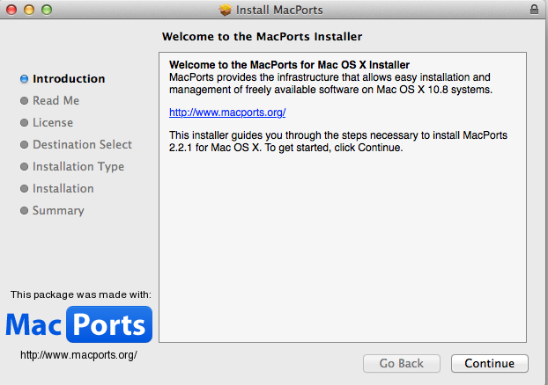

Install gphoto2 library:

1. locate your Terminal app. 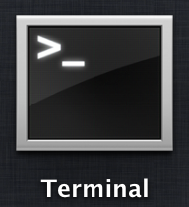
2. refresh system:

sudo /usr/libexec/locate.updatedb

1. locate and install the gphoto2 library:

port search gphoto2

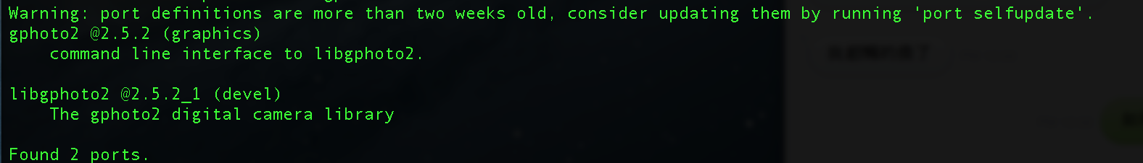

sudo port install gphoto2

Install Digital Control Server and Client interface:

1. download Digital Control Server from GitHub: <https://github.com/NIF-au/DigitalControlServer/archive/master.zip>
2. upzip the file and move to the file location to where you like.
3. Go back to Terminal app and locate your DC Server file path:

cd /Users/yourname/filepath/DigitalControlServer-master

* change yourname and filepath to yours

sudo make

1. download Digital Control Client interface from GitHub: <https://github.com/NIF-au/DigitalControl/archive/master.zip>
2. upzip the file and move to the file location to where you like.
3. Locate a file name called: Digital Control_v1.0.app (this is the built app for control interface. Other files are for developing purpose)

Run application:

1. before using DC Server application, please make sure you connect your DSL camera to your Mac computer using USB 2.0
2. go back to Terminal app and locate your DC Server file path then start DC Server by typing:

./camera_control_server

1. One camera control has initialized the camera, open the

Digital Control_v1.0.app by double click its simple: 

You will now see the connection status in the top of DC Client application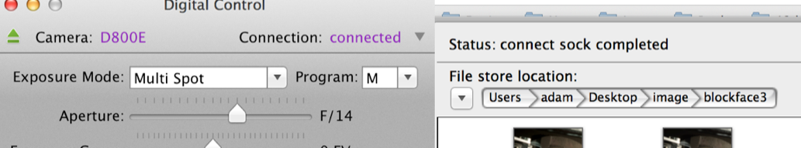

and now you are ready to rock and roll.